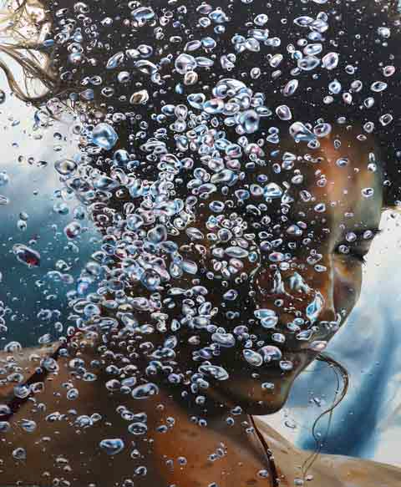

ERIC ZENER

RECENT PAINTINGS

April 13 – May 11, 2024

Gallery Henoch is pleased to present “Recent Paintings,” Eric Zener’s 19th solo show with the gallery. In this series of paintings, Zener explores the experience of solitude and its paradoxical connection to nature.

An opening reception will be held Saturday, April 13th from 5 to 7pm.

Zener has characteristically approached his work with an eye to articulating human encounters with life challenges. He often uses the natural world as a metaphor for moments of uncertainty and change. His waterscapes become backdrops for figures in contemplative states, while moments of euphoric revelation can be seen in dynamic plumes of white bubbles amplified by the surrounding blue.
While many of the paintings depict figures situated in water, several of them explore the mysteries of nature devoid of human presence. In these the viewer is introduced to a world characterized by densely forested views, idyllic fields, columns of bubbles, or towering cloud formations. Through both waterscapes and landscapes, Zener explores the abyss of nature and how it feels to be truly alone, removed from the world, and yet connected to a universal experience.

Eric Zener lives and works in the Bay Area and has been exhibited in the United States and internationally for over 25 years. The exhibition will be on view at Gallery Henoch from April 13th to May 11, 2024.

Gallery Henoch, 555 West 25th St. (between 10th and 11th Ave). Subway: C or E to 23rd St. Hours: Tuesday - Saturday, 10:30 am - 6:00 pm or by appointment. Free and open to the public. Contact the gallery at 1.917.305.0003 or info@galleryhenoch.com for additional information.
*Above depicted, REPRISE, Oil on Canvas, 60 x 48 in.

