FOR IMMEDIATE RELEASE March 6, 2024

STILL LIFE
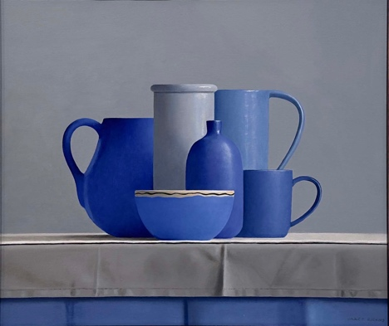
March 21 – April 12, 2024

Olga Antonova
Edward Butler
Samuel Hung
Robert C. Jackson
Elizabeth McGhee
Kevin Palme
Janet Rickus
Eric Wert

Gallery Henoch is pleased to present STILL LIFE, a group exhibition with eight artists who utilize still life painting as a means to explore human connection. Their paintings may range from nostalgic, to classical, to humorous, frequently using objects as a vehicle to engage their viewers. An opening reception for the artists will be held Thursday, March 21st from 6-8 PM. The event is free and open to the public.

In STILL LIFE, objects emerge as intricate layers, overlapping and obscuring each other, forming constructed realities that often reflect the human experience. In the case of Janet Rickus’s painting “Ensemble”, she uses classical techniques to position her bowls and fruits in a manner reminiscent of human relationships. The carefully picked vessels seem to mingle with one another, suggesting internal dialogues.

Human connection regularly relies on shared memories. Several of the artists use this trigger to remind viewers of times gone by. Samuel Hung and Edward Butler elicit wistful sentiments by incorporating old toys and objects, capturing the fleeting nature of memories. Similarly, Olga Antonova constructs towers of vintage porcelain teacups, evoking a quiet harmony that we are all sensitive to.

Humor and sarcasm also find a place in STILL LIFE. Robert Jackson and Elizabeth McGhee use props from the Americana era to create visual puns and tell a story. McGhee’s painting “Here Lies Pinocchio” perfectly represents how still lifes can be seen in a humorous light, bringing people together to share in a moment of light-heartedness.

The paintings by Kevin Palme and Eric Wert offer distinctive perspectives, employing bold colors that imbue their subjects with a palpable sense of vitality and energy. Both, Palme and Wert's work focus on ephemerality, highlighting the inevitability of change over time and outside forces. These concepts complement and expand upon the themes in STILL LIFE, offering viewers an exploration of the genre that celebrates its enduring relevance and versatility in contemporary art.

Works by Olga Antonova, Edward Butler, Samuel Hung, Robert C. Jackson, Elizabeth McGhee, Kevin Palme, Janet Rickus, and Eric Wert will be showcased in this group show.

Gallery Henoch, 555 West 25th St. (between 10th and 11th Ave). Subway: C or E to 23rd St.
Hours: Tuesday - Saturday, 10:30 am - 6:00 pm or by appointment. Free and open to the public.
Contact the gallery at 1.917.305.0003 or info@galleryhenoch.com for additional information.
***

